# My name is _____________________

I am ________________ years old.

On Saturday I am going to Festival of The Girl for a fun day out.

________________________________________

(*insert name/s*) will go with me to Festival of The Girl.

# Going to Festival of The Girl

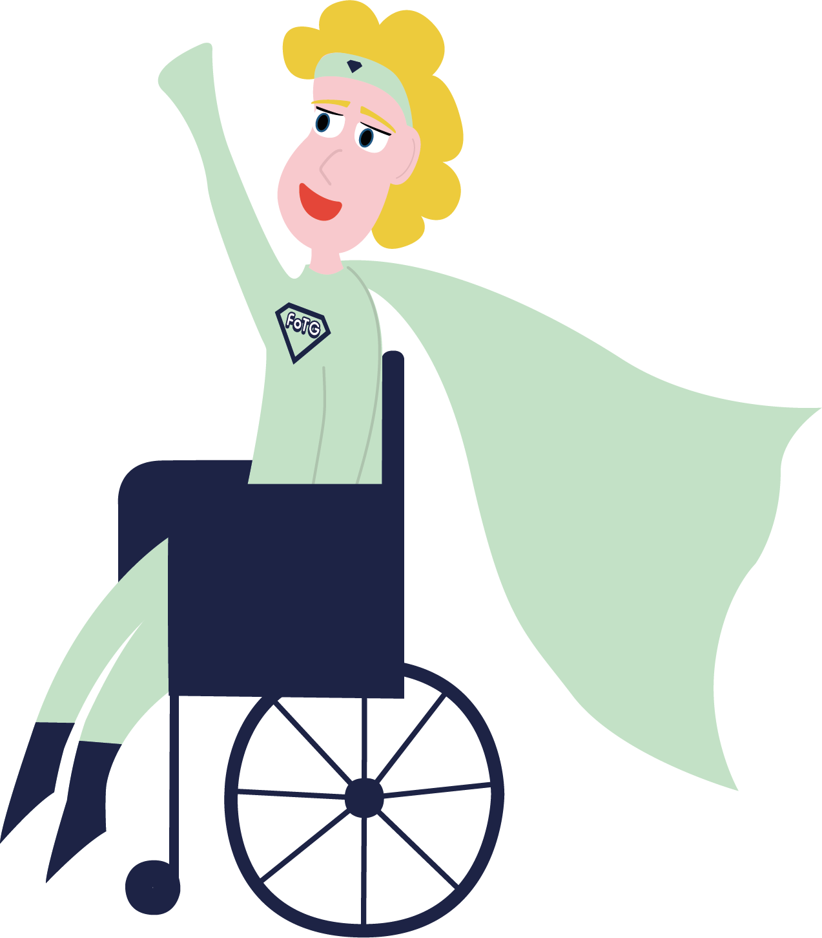

I will travel to Festival of The Girl by __________________________________________

When I arrive at Festival of The Girl I will go through the main entrance.

I might have to wait in a queue while they look at our tickets and check our bags.

That is ok.

I will be given a wrist band to wear if I want to.

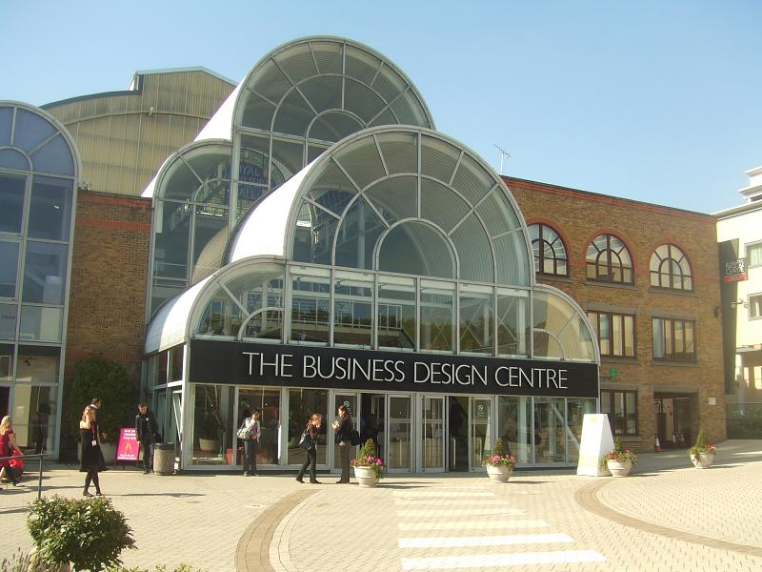__________________________________________

__________________________________________

(*insert travel plans*)

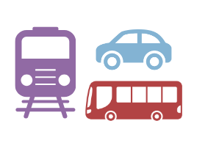

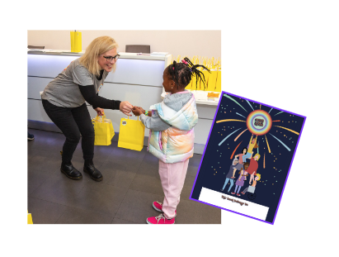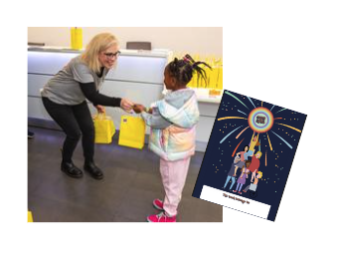

When I am in the festival there will be different activities I can try.

Here are some of the activities I can try if I want to:

* Boxing
* Yoga
* Building a bridge with marshmallows and dried spaghetti
* Using a drill (this can be noisy)
* Skateboarding
* Having my face painted
* Playing football and holding a trophy
* Arts and crafts
* Army bootcamp

I will go up an escalator or in a lift.

I will be given a goody bag with an activity book in it and then I will enter the festival.

The festival might be busy with other people, but I will be ok. I will be with ______________________

(*insert name/s*).

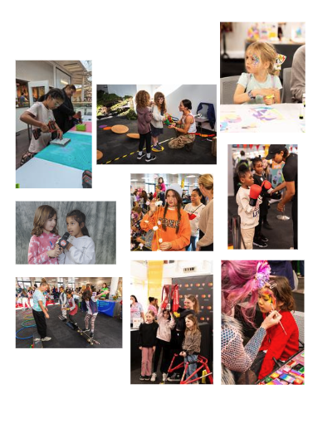

The activities that I would like to try are:

________________________________________

I can change my mind at the festival and try something different.

That is ok.

________________________________________

________________________________________

________________________________________

________________________________________

________________________________________

________________________________________

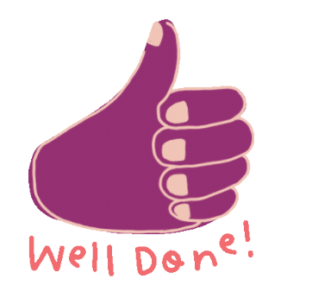

Although there will be lots going on I can take my time with ________________________________

(*insert name/s*) and have fun.

I can try something new if I want to.

If I don’t want to that is ok.

If I feel overwhelmed and worried that is ok. There is a quiet room I can use to relax.

When the festival is over, I will go home with my Festival of The Girl goody bag.

Going somewhere new is fun. I will learn new things. I will try something new if I want to.

Well done me!

